**Authors**: Peter Califano, Quinn Serfass, Tushar Saha

**Introduction**:  
Chemical leaveners like baking powder and baking soda use chemical reactions with acids and liquid to produce CO2 gas to leaven baked goods (Penfield, 1990). Baking powders are typically a combination of baking soda with an added acid to simplify the ingredients needed to produce a reaction. Double acting baking powders are designed to produce gas both when mixed with liquid and when exposed to heat. In this experiment we are interested in the effects of baking soda, baking powder, and a control on the height and diameter of chocolate chip cookies from a recipe that typically calls for baking soda.

**Methods**:  
Three batches of cookies were prepared, using baking soda, baking powder, or no leavener (control). We controlled variables by weighing ingredients and cookie dough balls, maintaining consistent baking conditions, and recording process timings. Cookie height and diameter were measured after baking, and data were analyzed in R.

**Results**:  
On average, cookies with baking powder had the greatest height (17.28 mm), followed by the control (16.80 mm), and baking soda (13.85 mm). Diameter results showed baking soda cookies were the widest (66.70 mm), followed by the control (60.55 mm) and baking powder (59.57 mm). ANOVA tests indicated significant differences in both height and diameter, with pairwise t.tests revealing that baking soda led to significant changes in both dimensions compared to other treatments.

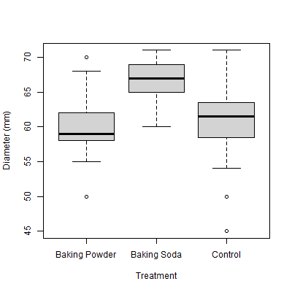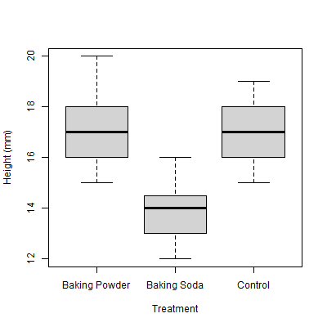

**Discussion**:  
The results contradicted our hypothesis; the control and baking powder batches had similar heights, while baking soda produced shorter, wider cookies. This could be due to baking soda’s effect on dough pH, which slows protein coagulation, allowing the cookies to spread more. Differences in pan type may have slightly impacted results, although not significantly. Future research could explore these leaveners in higher-moisture recipes or test the effect of adding acid to balance the pH with baking soda. Informal taste testing suggested that baking soda and baking powder cookies were preferred for texture, though this was not formally evaluated.

**Appendix**:

1. Recipe used for treatments.

1. Data table of results

|  |  |  |  |
| --- | --- | --- | --- |
| **Treatment** | **Avg Height (mm)** | **Avg Diameter (mm)** | **N** |
| Control | 16.80 | 60.55 | 20 |
| Baking Soda | 13.85 | 66.70 | 20 |
| Baking Powder | 17.28 | 59.57 | 21 |

1. ANOVAs for comparing diameter and height between treatments.

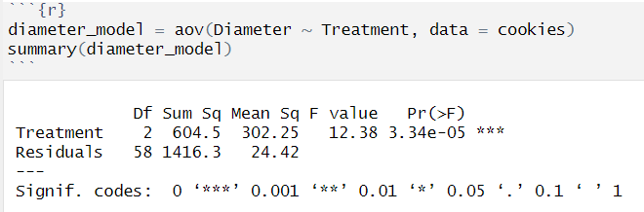

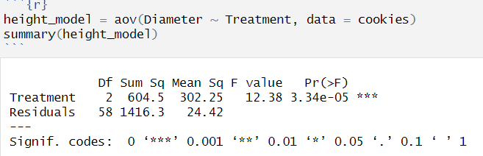

1. Bonferroni pairwise t.tests to compare significant differences between diameter and height between treatments.

# Bibliography

Penfield, M. P. (1990). *Leavening Agents*. Retrieved from sciencedirect: https://www.sciencedirect.com/topics/agricultural-and-biological-sciences/leavening-agent

Williams, C. (2023, January 24). *What Does Baking Soda Do In Cookies?* Retrieved from allrecipes: https://www.allrecipes.com/article/what-does-baking-soda-do-in-cookies/

**Full Text:**

**Introduction**:

Baking is not only a culinary effort, but also a scientific one, with precise quantities and ingredients having a substantial impact on the finished product. Leaveners are important ingredients in baking because they contribute to the texture and volume of baked goods. Baking soda and baking powder are two typical leavening ingredients used in recipes, each with their own chemical qualities and effects on the finished product.

Leavening in baking refers to the rise in breads, pastry, and cookies that occurs when gases trapped within the structure of the baked good expand due to the heat from baking. Historically baked goods have been leavened from (wild or sourdough) yeast that ferments starches and sugars to produce CO2 gas. More recently, chemical leaveners have been mass manufactured for quicker, easier, and more convenient rise in baking. These leaveners like baking powder and baking soda use chemical reactions with acids and liquid to produce CO2 gas (Penfield, 1990). Baking powders are typically a combination of baking soda with an added acid to simplify the ingredients needed to produce a reaction. Double acting baking powders are designed to produce gas both when mixed with liquid and when exposed to heat. We are interested in testing the leavening effects of both baking soda and double acting baking powder on cookies. Cookies, and in this experiment, chocolate chip cookies are relatively low acid and low moisture baked good, when compared to cakes or breads. In this experiment we are interested in the effects of baking soda, baking powder, and a control on the height and diameter of chocolate chip cookies from a recipe that typically calls for baking soda.

To confirm the validity and consistency of our findings, we took several steps for potential confounding factors. Such as keeping the quantity and quality of raw materials consistent, weighing each cookie dough ball to be of similar weight before baking, pre-heating the oven to the same temperature before baking and baking each batch over the same period of time. Regardless of our effort to account for confounding variables, it is critical to acknowledge that certain factors may still have influenced the experiment results, like variation in oven performance, human error while recording the measurements, etc. However, by following a strict process and controls, we hope we reduced these possible sources of variability.

The objective of this experiment is to look at the effect of various leaveners, notably baking soda, baking powder, and no leavener, on the form and size of chocolate chip cookies. By carefully altering the leavening agent used in the cookie dough, we aim to learn how these agents influence the physical properties of the cookies, specifically their height and diameter. We hypothesize that the control batch with no leavener will be the shortest batch, while double acting baking powder will see the highest rise with baking soda being in the middle. Through this experiment, we hope to gain a better knowledge of the science behind baking and contribute to the culinary skill of the development of delicious and visually appealing desserts.

**Methods**:

We followed the above recipe for all three batches of cookies. To avoid variability in ingredients as a confounder, all ingredients were weighed out ahead of time to ensure consistency in timing of mixing, dividing, and baking. The only difference in ingredients was that baking soda was subbed for an equal weight of baking powder in the baking powder batch. Additionally, we did not include a substitute or placebo for the control group as we believe it was more likely that any substitute would likely have more impact than simply leaving out any chemical leavener, as the leaverner only accounts for less than 1% of the dough by weight.

We mixed and prepared the control batch first, followed by baking soda and finally baking powder. Once a batch was placed in the oven to bake, we began on the next batch to ensure that the dough did not sit out for extended periods of time to avoid changes due to dough temperature. Refrigerated ingredients like butter and eggs were allowed to come to room temperature before mixing the doughs to avoid temperature discrepancies as confounders. Dough ball weights were determined by weighing the first batch of dough and dividing by 24 and rounding to the nearest whole number. Each dough ball was weighed to 30g +/- 1g to ensure consistent size of cookies to avoid dough ball size as a confounder. Once all dough balls in a batch were weighed, we baked the batch immediately, however due to space on pans we were limited to 20-21 cookies per batch.

To avoid confounders in process times, several timing-based processes were recorded for the initial control batch and identical timing was repeated for subsequent batches for consistency of process. Butter was creamed for 2 minutes, sugar was mixed in for 1 minute, eggs and vanilla for 20 seconds, flour mixture for 1 minute. Cookies were baked on the same rack in the oven at 350f for 6 minutes, then the trays were rotated 180 degrees and cookies were baked for another 8 minutes to ensure that hot spots in the oven did not introduce confounding variables. Once removed from the oven cookies were pulled off trays and left to cool on parchment paper.

Measurements were taken by one person using a measuring tape. We measured rise by the height of the cross section of the cookies. Cookies were cut in half and their height and longest diameter measurement were taken. This data was recorded into excel, and the data was analyzed in R.

Above: Control

Above: Baking Soda

Above: Baking powder

**Results**:

The table below shows the average heigh of each treatment, with baking soda having the lowest average height of 13.85mm, control having the next lowest height of 16.80mm and baking powder having the highest average height of 17.28mm. Diameter was also measured, with baking soda having the highest average diameter of 66.70mm, the control having the next highest average diameter of 60.55mm and baking powder having the lowest average diameter of 59.57mm.

|  |  |  |  |
| --- | --- | --- | --- |
| **Treatment** | **Avg Height (mm)** | **Avg Diameter (mm)** | **N** |
| Control | 16.80 | 60.55 | 20 |
| Baking Soda | 13.85 | 66.70 | 20 |
| Baking Powder | 17.28 | 59.57 | 21 |

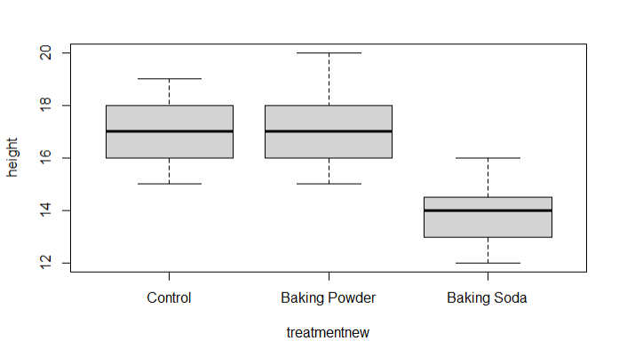

An ANOVA was used to determine whether the differences in height and diameter between the treatment groups are significant. We can tell this by comparing the variances of all the treatments and seeing if they are similar.

The figure below shows the results of this ANOVA. With p<0.05, and a high F value (12.38). From this test, we can conclude that there is a significant difference between the diameter of the cookies between some of the treatment options.

The below figure shows the results of an ANOVA comparing the height of the cookies between treatments. From this test, we can see that with a p<0.05 and a high F value (50.71) that there is a significant difference between the height of the cookies between some of the treatment options.

After understanding that that both height and diameter can be attributed to the treatment type, we wanted to compare each treatment to each other to see if they have any significance. To determine which treatments are significantly different in height and diameter, we ran pairwise t.test to do multiple comparison between the treatments. We applied a Bonferroni correction to control for type 1 errors. From the results below we can see that there is a significant difference in diameter between baking soda and baking powder (p<0.05) and that there is a significant difference in diameter between baking soda and the control (p<0.05), however we do not see a significant difference in diameter between baking powder and control (p> 0.05).

Similarly, in terms of height, we can see that there is a significant difference in height between baking soda and baking powder (p<0.05) and that there is a significant difference in height between baking soda and the control (p<0.05), however we do not see a significant difference in height between baking powder and control (p>0.05).

Baking powder appears to have more variance and range as the max height reached 20mm compared to the control which reached 19mm while both sat at 15mm for the minimum. For diameter, the variance for the control group was the highest.

**Discussion**:

Based on the results above, we can reject our hypothesis that the control group will have the least height, the baking soda group will have the next most height, and the baking powder group will have the most height. Our results show that there is no significant difference between control and baking powder, while baking soda was significantly shorter than the other two treatments.

Our results reflect what was visually obvious, the baking soda cookies were noticeably shorter and wider than the control and baking powder batches. The baking powder and control cookies were nearly indistinguishable. While this is counter to our hypothesis that the control batch would be the shortest, height does not necessarily translate to quality in terms of cookies, and the baking soda batch was noticeably closer to what would typically be a traditional chocolate chip cookie. It is also important to highlight that the recipe used called for baking soda, meaning that the impact of leaveners may be different depending on the recipe used, especially if you consider the low water content of the cookies in this experiment.

One potential effect of the baking soda that caused a significant difference is the change in pH caused by introducing a base to the recipe. In contrast with baking powder, which contained both base and acid, baking soda likely raised the pH of the dough sufficiently to slow the coagulation of proteins introduced by the eggs, giving more time before the eggs in the cookie sets, resulting in a wider and flatter cookie (Williams, 2023). This would also explain the lack of difference between baking powder and the control, as both neither would drastically change the pH of the dough, and the lack of water content in the dough would prevent the baking powder from giving a rise. Meaning that the height we see is likely the effect of the cookie setting quickly during baking and not the result of a rise like we typically see in cakes or breads. This suggests that the purpose of baking soda within the recipe is primarily for pH adjustment and not its leavening properties.

One potential confounding variable that was not controlled for was the sheet pan used. We used three different sheet pans of varying size during the experiment which likely resulted in the control and baking powder treatments being darker on the bottom than the baking soda, however we do not believe that this had a significant impact on the height and diameter of the cookies. Future experiments should control this by using consistent pans for each batch of cookies to ensure we do not see an effect from the type of pan used.

Future experiments may want to examine the leavening effects of the leaveners used in higher water content baked goods like cakes or breads to determine the leavening effect with enough water present. Additionally, we may want to examine the water content needed to properly activate chemical leaveners. We can also test the proposed hypothesis that it was the pH that led to shorter, wider cookies in this experiment by adding an additional treatment to the experiment of baking soda and acid to balance the pH.

Ultimately the experiment was delicious, and all batches were very good. Informally, of those we invited to eat some of the (60+!) cookies we baked, most preferred the baking soda or baking powder cookies. The baking powder cookies appeared to have improved texture over the control cookies despite being very similar, however we did not formally taste test the cookies, which could be for a future experiment.